STT Lab1

Name=Banavath Diraj naik Roll no=22110044

# Introduction, Setup, and Tools

### Overview

The fundamentals of Git, a distributed version control system that is frequently used in software development to track changes and promote collaboration, were examined in this study. Among the tasks were integrating with remote repositories on GitHub, setting up Git, initializing a local repository, managing files through staging and committing, and putting in place a continuous integration workflow with GitHub Actions and Pylint for code quality assurance.

#### Objectives

* Set up Git using the proper user credentials.
* Create a local Git repository and maintain it.
* Execute commit actions and file staging.
* Create a connection between GitHub and the local repository.
* GitHub allows you to push local commits to a remote repository.
* Existing GitHub repositories can be cloned to the local environment.
* To maintain synchronization, pull updates from distant repositories.
* Use GitHub Actions to set up a pylint workflow that guarantees code quality.

#### Environment Setup

* Set up Git on the local system.
* Create repositories and register for a GitHub account.
* Set up Git using your login information.
* Install Python3

### Tools and version used

* Git: Version 2.30.1
* GitHub: Web-based platform for version control and collaboration.
* Python: Version 3.9.1
* pylint: Version 2.6.0
* GitHub Actions: Continuous integration service provided by GitHub.

# Methodology and Execution

## Git Basics

* Setting up Git:

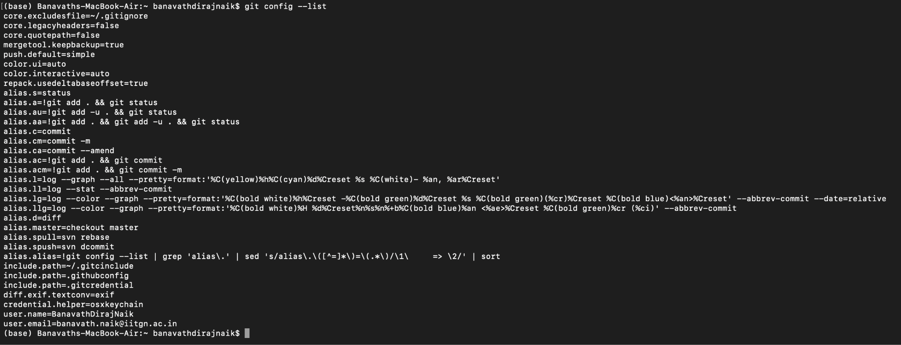

* Initializing a Local Repository:

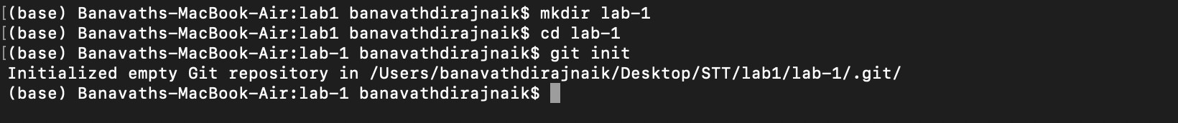

* Adding and Committing Files:

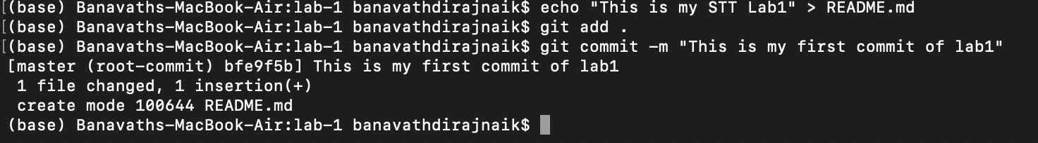

* Viewing the Commit History:



## Working with Remote Repositories

* Connecting to GitHub:



* Pushing Changes to GitHub:

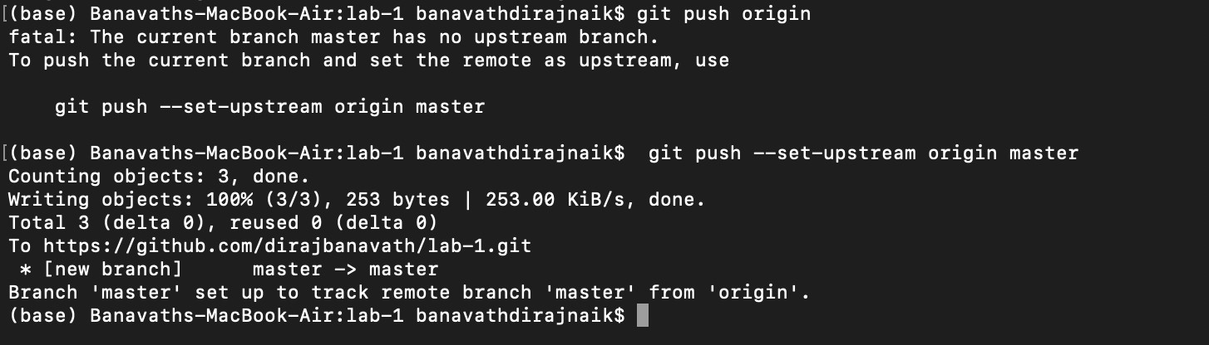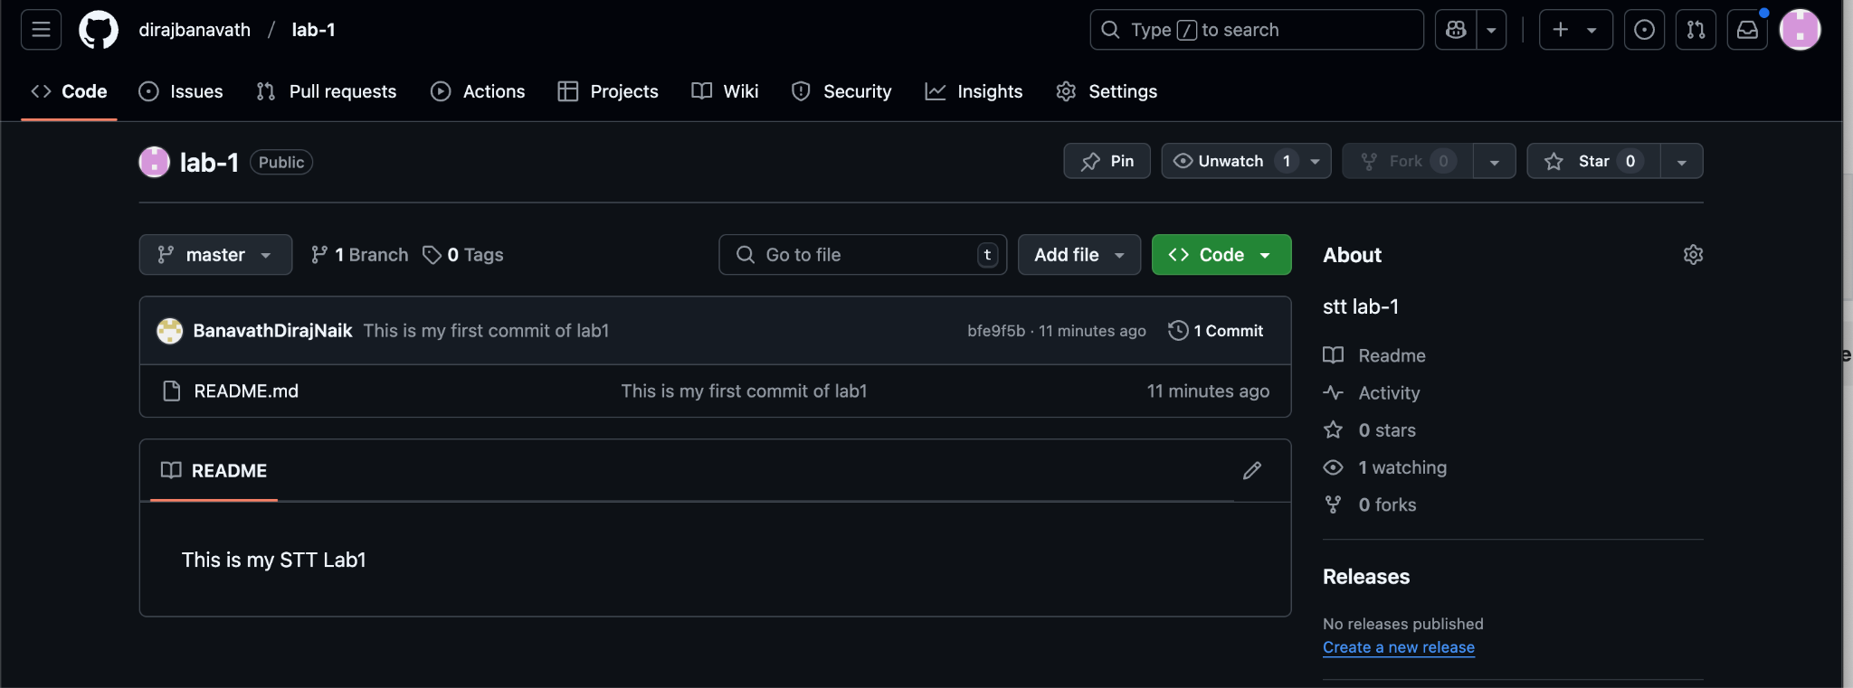

* Cloning a Repository:

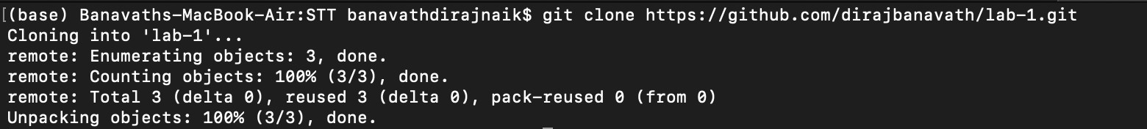

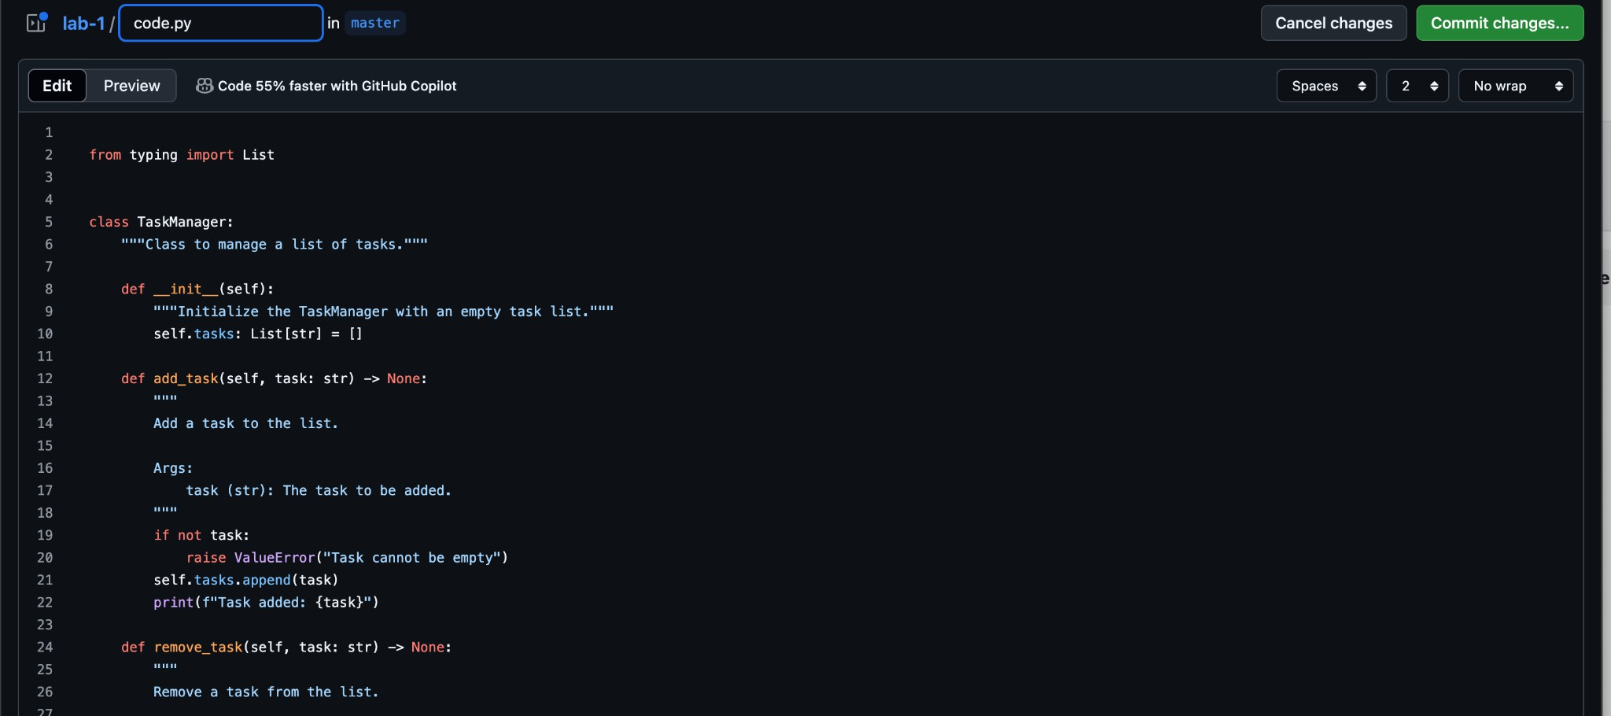

* Pulling changes:

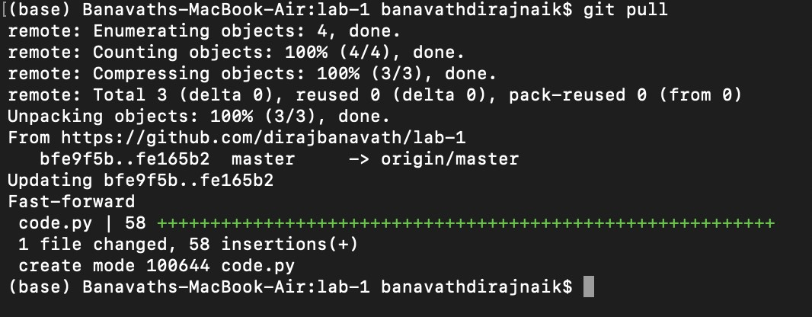

## Setting up pylint

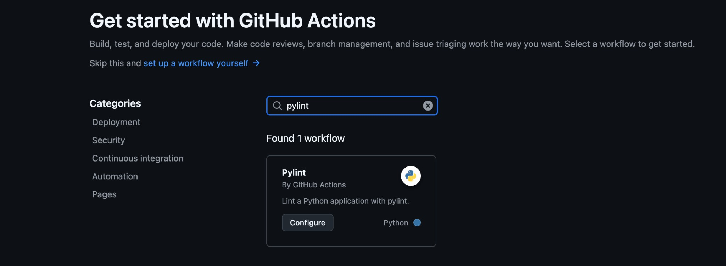

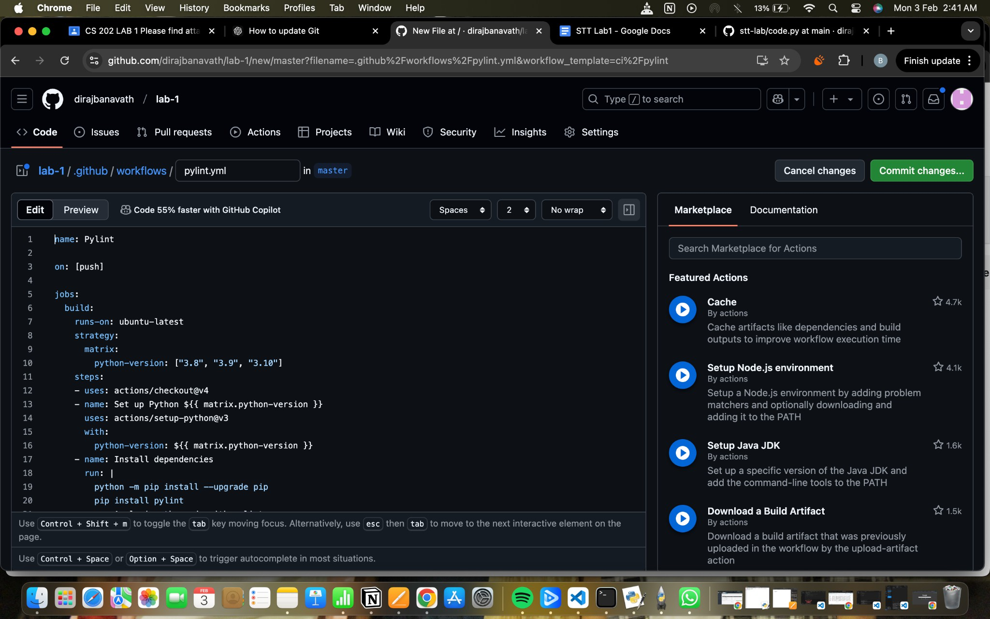

Got a docstring error after adding it error is resolved

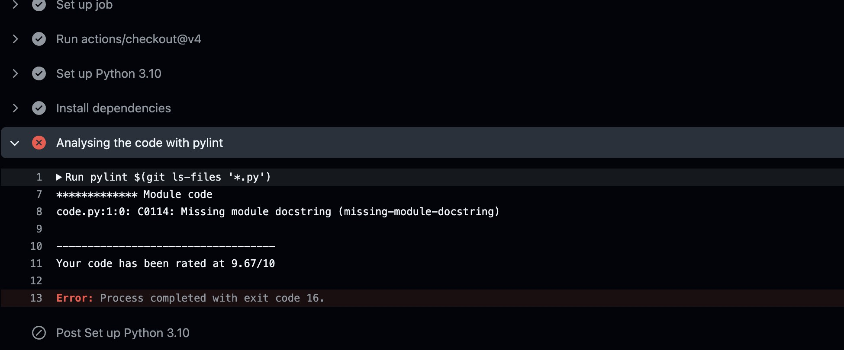

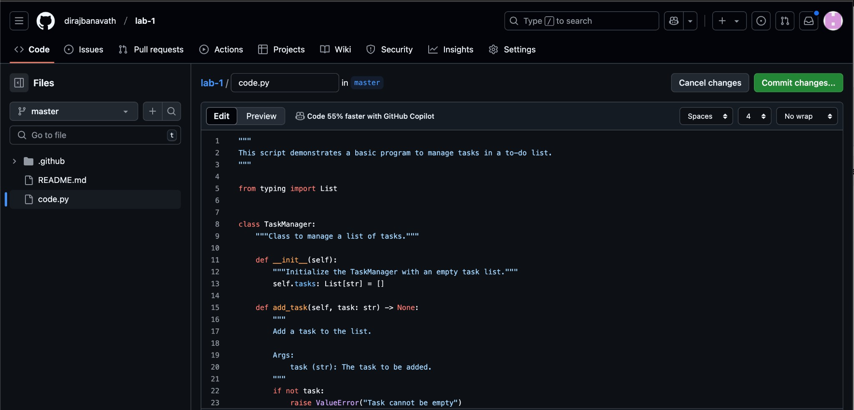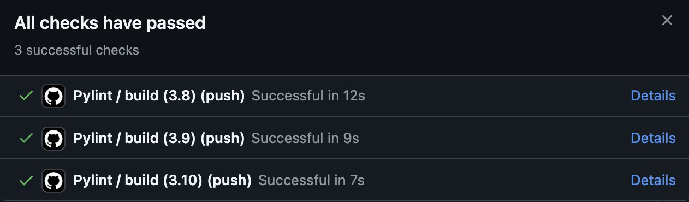

# Results and Analysis Outputs

* successfully set up user credentials and initialised a local Git repository Any_Name.
* A README.md file was created and added to the repository.
* successfully connected to a remote GitHub repository and pushed changes.
* GitHub Actions' pylint workflow was put into place, and all linting issues were fixed.

# Observations

* Git's branching structure made it simple to collaborate and maintain code versions.
* Using GitHub Actions to automate linting greatly increased the uniformity and quality of the code.
* The local and remote repositories were kept in sync by pushing and pulling updates.

# Key Insights

* Appropriate commit messages facilitate efficient change tracking.
* Readability was enhanced and coding standards were enforced by using pylint.
* For collaboration to run smoothly, merge conflicts must be understood and resolved.

# Discussion and Conclusion Challenges

* YAML syntax mistakes caused early setup issues for GitHub Actions for Pylint.
* When working with numerous branches, merge issues were encountered.
* Debugging was necessary to comprehend and understand pylint warnings.

# Reflections

* Code monitoring and debugging are made easier with frequent commits and unambiguous commit messages.
* Workflows for automated linting improve the consistency and maintainability of code.
* Effective version control requires knowledge of Git commands and workflows.

# Lessons learned

* Version control's significance in cooperative development.
* the advantages of utilising GitHub Actions and other continuous integration tools.
* Successful branch management strategies to prevent disputes.

# Summary

This lab reinforced the value of version control in software development by giving participants practical experience with Git and GitHub. I improved code quality and learnt about automated workflows by putting GitHub Actions for Pylint into practice. The difficulties I encountered helped me learn a lot and strengthened my comprehension of version control systems.